METHODOLOGY

With the objective of understanding how green gentrification has been analyzed in the context of the Global South, a comparative analysis of multiple case studies⁷³ was conducted, based on a literature review⁷⁴ (Cronin et al., 2008). For this purpose, searches for scientific articles were carried out in the Scopus, Web of Science, Scielo, and Google Scholar databases, using the following search strings:

- ("green gentrification" OR "environmental gentrification" OR "ecological gentrification" OR "climate gentrification") AND ("global south" OR "latin america" OR brazil)

- ("gentrificação verde" OR "gentrificação ambiental" OR "gentrificação ecológica" OR "gentrificação climática") AND ("sul global" OR "américa latina" OR brasil)

After the initial reading of titles, abstracts, and full texts of the articles, those presenting well-defined case studies were selected. Out of the 38 articles found, 17 met the highlighted selection criteria. One article considered seminal in the Brazilian context, cited by some authors of the analyzed articles, was added. Figure 1 presents, in a structured way, the stages of article search and selection.

Fig. 1. Steps of the literature research processes.
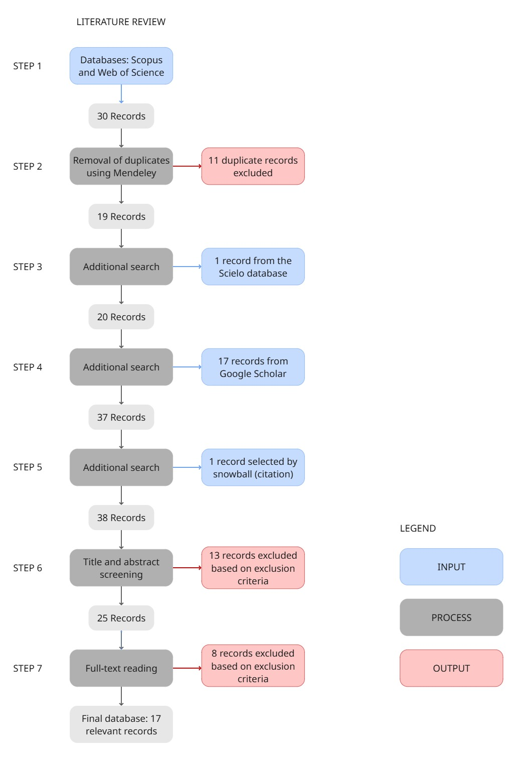
Source: The authors, 2025, based on Sousa⁷⁵.

The purposes of this review were: (a) to build a qualitative synthesis of knowledge on how green gentrification can be observed in the Global South; (b) to identify the existence of patterns of processes and actors involved in the set of selected case studies; and (c) to compare the identified patterns with the case study of the Banhado community, in the municipality of São José dos Campos (SP), to verify whether this case can be characterized as a type of green gentrification.
Two basic questionnaires were developed for the analysis. Questionnaire 1 (Table 3) listed fundamental criteria regarding the articles, and Questionnaire 2 (Table 4) focused on the case studies.

Table 3. Questions from Questionnaire 1: About the article.
Questions | Alternatives
1) Term used in the article by the authors in the keywords | Green Gentrification; Environmental Gentrification; Ecological Gentrification; Climate Gentrification; None; Other
2) Year of publication of the article | Open value
3) Place of publication of the article | Global South journal; Global North journal
4) Authors' research institutions | Institutions from the Global South; Institutions from the Global North; Both
5) Number of citations in Google Scholar | Open value
6) Methodological approach of the article | Qualitative; Quantitative; Mixed methods
7) City and country of the case study | Open information
Source: The authors, 2025.

Table 4. Questions from Questionnaire 2: About the case studies.
Questions | Alternatives
1) When was the intervention project carried out? | Open value
2) The gentrification process: | Has already occurred; Is occurring; There is a risk of occurring
3) Type of investment | Public; Private; Public-private partnership; Public and private; Not mentioned
4) Was there social participation? | Yes; Yes, partially; No; Not mentioned
5) Income profile of the area's population | Low; Medium; High; More than one profile; Not mentioned
6) Was there forced removal or threat of removal? | Yes; No; Not mentioned
7) Was there resistance from residents? | Yes; No; Some resisted, others accepted; Residents moved but were dissatisfied; Not mentioned
8) Evidence of gentrification | Open information
9) Were there initiatives to prevent gentrification? | Yes; No; Not mentioned
10) Prevention mechanisms mentioned by the authors? | Yes; No
11) Were benefits reported despite gentrification? | Yes; No or not mentioned
Source: The authors, 2025.

The case study of the Banhado community was constructed based on secondary data. A bibliographic review of scientific articles about Banhado was conducted, as well as consideration of online news articles, specialized blogs, and data released by the local city hall. The Banhado case was chosen because it dialogues with the multiple case studies raised in the literature review and can contribute to this set. It is understood that the conflict occurring in the community aligns with the critical lenses of green gentrification in the Global South. Paradoxically, while São José dos Campos was one of the pioneering municipalities in Brazil regarding the inclusion of NbS and GI concepts in its municipal master plan (Table 1), a socio-environmental and land tenure conflict involving threats of removal in the city center has persisted for years, without a critical analysis correlating and highlighting this contradiction from the perspective proposed in this work. The absence of primary data collected in situ is characterized as a limitation of this study.
The comparative analysis of the multiple case studies and the individual case study of Banhado was presented in the results section. The theoretical framework was constructed through a narrative literature review and document analysis.

